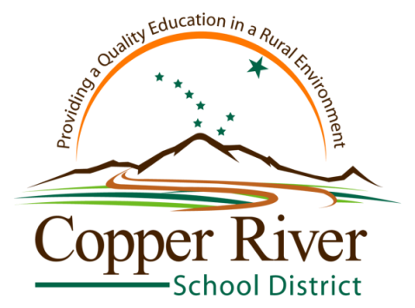

Jim Lorence
Office of Guidance & Counseling
Glennallen Office: P.O. Box 108 Glennallen, AK 99588
Phone 907.822.5286 FAX 907.822.8501

• • Glennallen • Kenny Lake • Slana • Upstream Learning •

December 14, 2014
Greetings Senior Parents! Can you believe that graduation is only a little over five months away? Here are a few items of information to assist you and your student in planning.
Financial Aid Presentation-On Monday, January 12th, I am having a parent financial aid night. A representative from the Alaska Commission on Post-Secondary Education will be coming out to share information on the financial aid process that students typically go through their senior year. She will be covering the FAFSA, as well as grants, loans, and scholarships. In addition, she will be discussing the Alaska Performance Scholarship. She will be at GHS, but will present to Kenny Lake and Slana via VTC. Start time is 630 pm. Please see the attached flyer for details.
University of Alaska Scholarship Opportunities-For students planning to attend any branch of the University of Alaska system, I want you to know that there is a February 15th deadline for their scholarship application. You must have applied for admission, submitted your FAFSA, and completed the scholarship application by this date. This is a very important scholarship application to complete. For more information:
• UAF (University of Alaska Fairbanks)-www.uaf.edu/finaid/scholarships/
• UAA (University of Alaska Anchorage)-www.uaa.alaska.edu/scholarships/
• UAS (University of Alaska Southeast)-www.uas.alaska.edu/finaid/scholarships/
• Prince William Sound Community College-www.pwscc.edu/admissions/financial-aid-scholarships/
Scholarships: Students should be checking, on a weekly basis, the Guidance & Counseling page of the Copper River School District website for a listing of scholarship opportunities. Go to www.crsd.us
Then click on Students & Parents; then click on Guidance & Counseling. This will take you to a list of scholarship opportunities as well as other items.
Parents: On my Guidance & Counseling page of the Copper River School District website, I have a Parents tab. Be sure to check that out also! This page is an important method of my communication to you, so please check it regularly.

Applications: If your student is planning to apply to a particular college, vocational school, apprenticeship program, or other program—and has not yet done so—don’t delay! While it’s not too late yet, the sooner you apply, the better! If you would like to meet in person, or talk by telephone, I’d be glad to answer any questions you might have.
Alaska Performance Scholarship: In addition to meeting particular course requirements, students must meet minimum GPA and SAT, ACT, or Workkeys scores to quality. Detailed information on APS requirements can be found here:
http://acpe.alaska.gov/STUDENT-PARENT/Grants_Scholarships/Alaska_Performance_Scholarship
In particular, I encourage you to check your student’s SAT and ACT scores to see if they meet minimum requirements. Remaining opportunities to test this year are as follows: SAT-January 24th and May 2nd; ACT-April 18th. Registration deadlines must be met and can be found on the attached page or Guidance & Counseling page of the CRSD website.

As always, please feel free to contact me should you have any questions.

Mr. Lorence, Guidance Counselor
822-5286 Glennallen High School
Email: jlorence@crsd.us

