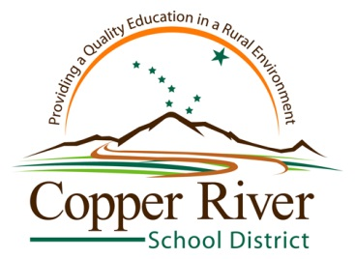
Work Experience
STUDENT AGREEMENT

- A student may earn up to 1.0 credit during the school year or up to 1.0 credit during the summer. A maximum of 1.0 credits may be earned towards a diploma.
- Credit is awarded at a rate of 180 hours per .5 credit (or 360 hours per 1.0 credit).
- Credit is only awarded if all assignments have been completed and the student earns a grade of 80% or higher. Note that all assignments must be completed before credit will be granted!
- Grades are Pass/Fail only. No letter grades will be given.
- A student must find their own job placement. Paid or non-paid positions are acceptable.
- A student must submit a Student Agreement, Work Experience Plan, and participate in a Career Guidance & Eligibility Session PRIOR TO beginning the work experience.
- Students will provide their own transportation to and from the workplace. The parent will be responsible for the safety and conduct and of the student while traveling to the workplace.

The work experience program has been explained to me and I understand and agree to the terms.

Place of Employment: Click here to enter text.

Amount of credit I am desiring (enter .5 or 1.0 credit): Click here to enter text.

Term (enter Fall, Spring, or Summer): Click here to enter text.

School Year: Click here to enter text.

Student Signature:____________________________________________ Date:______________

Parent/Guardian Signature:_____________________________________Date: ______________

Workplace Supervisor Signature:_________________________________Date:______________

Work Experience Coordinator:___________________________________Date:______________

