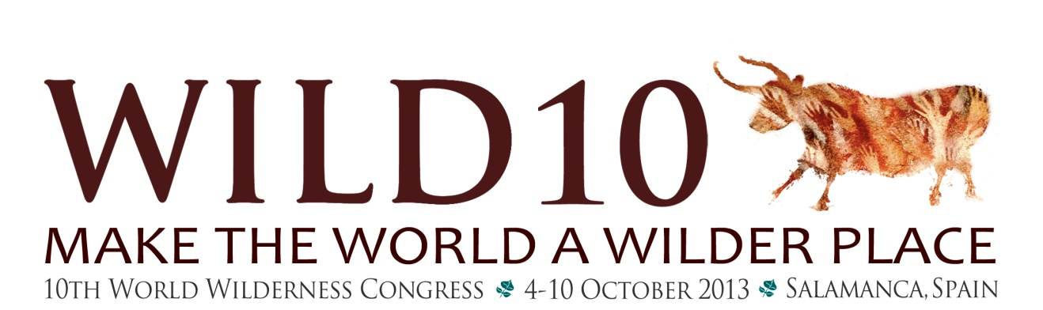

GenWILD Mobilizing a generation to create a wilder, better world

To Students Ages 14 -19
(must be 14 by April 1, 2013)

WILD10 is an empowering platform for youth to create a global conversation on conservation. To share ideas, design a project and implement that project to make the world a wilder place and refine and sustain the vision that Nature Needs Half. School credit applies.

Students will:
- Develop a presentation on what wild means to you.
- Attend the World Wilderness Congress in Salamanca, Spain, October 4-10
- Learn with other youth from around the world
- Develop and implement a project that makes the world a wilder place. Complete project within a year
- Raise $1,000 toward the Spain trip.
How to Apply: (Two students from the Copper Basin will be selected)
- Go to the Wrangell Institute for Science and Environment (WISE) web site, www.wise-edu.org and click on WILD10.
- Read all the information about WILD10 and get parents' permission to apply
- Fill out the application and send to appropriate contact by April 1.

For more information contact Janelle Eklund, 822-3282 or 259-3282; jeklund@cvinternet.net

