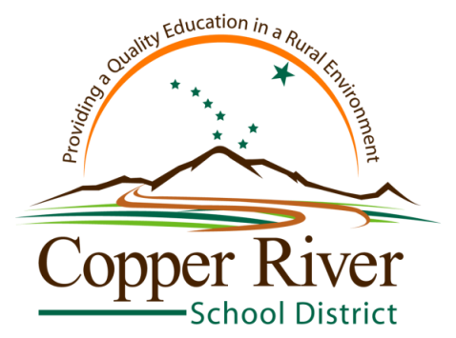

Jim Lorence
Office of Guidance & Counseling
Glennallen Office: P.O. Box 108 Glennallen, AK 99588
Phone 907.822.5286 FAX 907.822.8501
http://counseling.crsd.us • jlorence@crsd.us

• • Glennallen • Kenny Lake • Slana • Upstream Learning •

Counseling Calendar 2015-16

September 10: Senior Parent Night
September 14: Armed Services Vocational Aptitude Battery @ Glennallen
Oct. 3: SAT @ Glennallen
October 14: PSAT @ Glennallen and Kenny Lake School
October 23-31: National Red Ribbon Week; Assemblies at the schools: Kenny Lake (Oct. 20); Glennallen (Oct. 21); Slana (Oct. 22)
Dec. 12: ACT @ Glennallen
January 13: Free Application For Federal Student Aid (FAFSA) Presentation For Seniors & Parents (Parent night Jan. 13; School presentation Jan. 14)
Jan. 23: SAT @ Kenny Lake
March 1: In-School ACT testing (juniors)
March 2: In-School SAT and Workkeys testing (juniors)
April 9: ACT @ Kenny Lake
May 7: SAT @ Glennallen

For additional testing information, please see the Copper River School District College & Career Testing document located on the Guidance & Counseling page of the CRSD Website

