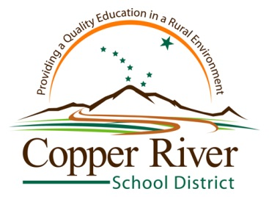
Career Clusters and Sample List of Placements in the Copper Valley

Agriculture, Food & Natural Resources: Bureau of Land Management
Architecture & Construction: O & S Construction
Arts/ Audio-Visual/Communications: KCAM Radio
Business Management & Administration: Ahtna, Inc
Education & Training: Copper River School District
Finance: Wells Fargo; First National Bank Alaska
Government & Public Administration: United States Post Office
Health Science: Crossroad Medical Center; Glennallen Chiropractic; Dental Office
Hospitality & Tourism: Caribou Hotel/Restaurant
Human Services: Copper River Native Association; Pregnancy Center
Information Technology: Copper Valley Telephone; Copper River School District Tech Department
Law, Public Safety, and Corrections: Alaska State Troopers
Manufacturing: Copper Valley Electric Association
Marketing: Sparks General Store
Science, Technology, Engineering, & Math: National Park Service
Transportation, Distribution, & Logistics: Napa Auto Parts; Glenn Transport

