Adrina’s
Memorial Scholarship
To
Promote positive, passionate living.

In Memory of
Adrina Louise Knutson
February 16, 1991 – August 6, 2012
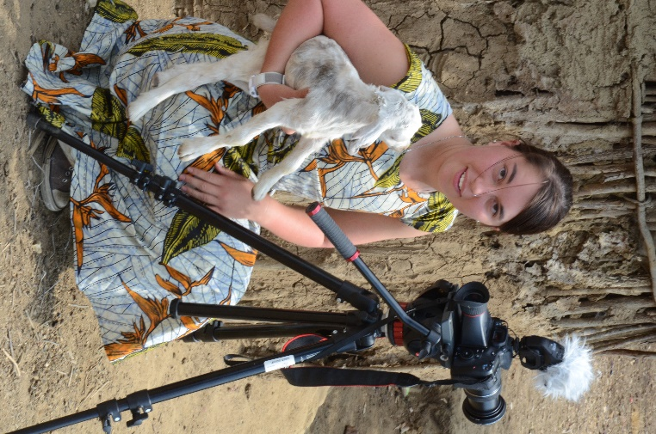

Financed by
the generous contributions of family, friends and community businesses and organizations.

(Scholarship #1)
University of Alaska, Fairbanks
Juniors and Seniors
Film Majors

(Scholarship #2 -Special request funding)
Copper River School District Graduates from 2009 through 2015
(CRSD Scholarships will be awarded from May 2013 thru August 2015)

Adrina’s
Memorial Scholarship
To
Promote positive, passionate living.

Adrina was born and raised in Kenny Lake, Alaska. She was the oldest of the four Knutson girls. For 12 years she attended Kenny Lake School, one of two K-12 schools in the Copper River School District, where her sisters have also attended (classes of ’11, ’13, and ’15). After graduating co-valedictorian in 2009 she attended three years at the University of Alaska, Fairbanks immersed in their newly established film program. Her love for film emerged through the training she received while at Kenny Lake School with the numerous film projects she participated in. As this creative process grew within her she was rarely seen without a camera or mulling over an idea that required a camera. She was intrigued by photo as well as video.
Though Adrina was involved in many projects and activities she was quite selective. She either had a strong passion for the activity or felt her involvement was necessary and would make a needed difference in its success. Some of Adrina’s favorite activities were dancing, playing pick-up hockey in the cold, drawing, cooking and “playing” with her sisters and friends; in these she was grounded in her knowledge that God loved her and she was safe in his arms.
Adrina was quite exuberant and this positive attitude opened many doors for her. This outlook and her growing skill made it possible for her to work behind the camera for “Fairbanks Focus” and to be part of three big projects in her final year of life at the young age of 21. For her local Community League she filmed and produced a 45 minute historical video, “Home^{3 “}, documenting the settlement of Kenny Lake thru homesteading seen through the eyes of three generations. “Breath in the Light” asked her to be their sound man as they hiked Kesugi Ridge in Denali Park, acquiring footage to produce a film to be used in the healing process of abused Alaskan women. And her final touch on the world around her was the honor of being selected to travel with UAF and San Francisco State University to Tanzania, Africa. While there she would be filming the Maasai people within their homesteads documenting their traditional lifestyle and creating films to inform the Maasai of consequences of migration. It was there that Adrina passed from this world into the arms of her Savior following a horrific auto accident that left her fellow students severely injured and changed the lives of her professors and Maasai interpreters and driver.
Though Adrina was involved in many projects, her greatest contribution in this world was her positive outlook and its effect on all those she met. People were important to her; she would always reach out, extend a helping hand, offer a smile, give a word of encouragement. She strongly believed this world wasn’t put here to cater to her, but she was put here to give all she could to make it a better place – and in doing so her life would be better. And so it proved true.
Thank you Adrina for understanding and living your life the way God intends us all to.

Adrina’s
Memorial Scholarship
To
Promote positive, passionate living.

To Apply:
Scholarship #1 – UAF junior and senior film majors: Not yet available; In the process of raising funds to create an ongoing scholarship.

Scholarship #2 – CRSD graduates (2009-13) and high school seniors (2014).
HS Seniors: submit to: Tony & Julie Knutson, HC60 Box 229K, Copper Center, AK 99573
- Transcript
- Essay: No less than two pages double spaced.
- Two letters of reference with contact information. Select individuals who can best support your essay.

Graduates: submit to: Tony & Julie Knutson, HC60 Box 229K, Copper Center, AK 99573
- Name (please include name at time of graduation if it has changed)
- Address and phone number
- CRSD High School from which you graduated and the year.
- Unofficial transcript from College/University/vocational school and program
presently attending or completed, or a financial statement. (You must still have outstanding loans if the program has been completed- Include loan holder.)
- Year of anticipated graduation or date of completion and degree or certification received.
- Essay: Two or more pages; double spaced.
- Two letters of reference with contact information. Select individuals who can best support your essay.

Class of 2015: Not eligible until senior year.

Essay prompt: In no particular order: tell us about yourself, what your dreams are, what is it about life that intrigues you the most and if it could would fill your days (your passion), and what you do that contributes to the lives of others making this world a better place. (Don’t forget how your schooling fits in as this is a scholarship to help fund your education.)

Deadline for 2014-15 school year: March 30th, 2014.
- High School Senior recipients will be announced at their graduation ceremony.
- High School Graduates will be notified by mail and also be announced at the high school graduation ceremonies.
- Postsecondary school graduates will be notified by mail.

These scholarships will be no more than $1000 and no less than $500. Scholarships will be granted until all designated funds have been distributed. Students may apply again if they didn’t receive a scholarship in previous years.

